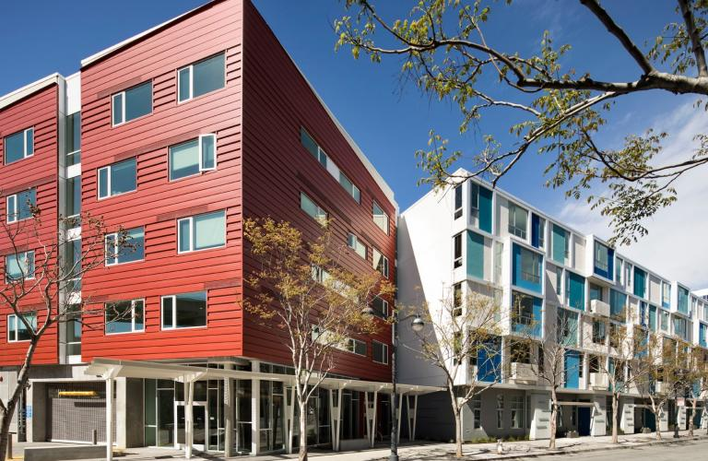  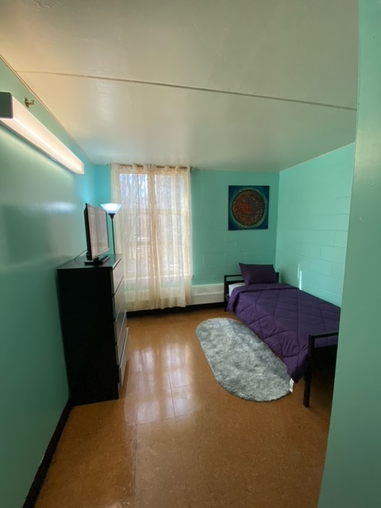  - Agency / Program name  Program / Unit Highlights  Use this paragraph to provide a brief description of the available housing, the program, and/or the most important thing that interested future residents would want to know about the unit or program. Think about why a future resident would choose this particular unit or program and put that information here.  *Sample unit  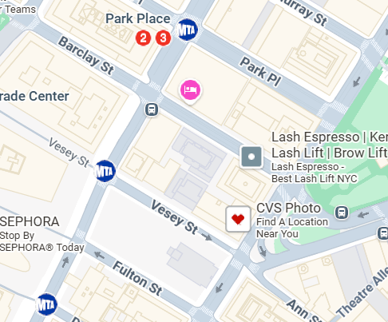  We look forward to meeting you at the interview!
  Amenity #1
  ____
  Amenity #2
  ____
  Amenity #3
  ____
  Amenity #4
  ____
  Amenity #5
  ____
  Nearby Transit
  B
  B
  B
  B
  B
  T
  T
  T
  T
  T
  program name
  Street Address
  City, State ZIP Code
  Telephone
  Web Address
  Questions?
  Email Address

